Multi-dimensional constrained sampling
Fast Flexible Space-filling Design for Non-rectangular Regions

Abhijith.S.D
(2nd Year) Department of Computer Science
CORI,PESIT
Bengaluru,India
abhinomega135@gmail.com

Abstract—This paper explains a fast and nice way to sample required number of samples in a multi-dimensional parameter space with the parameters satisfying certain constraints with their own distributions
Keywords—space-filling; design of experiments; clustering; computer experiments

Introduction
For many scientific phenomena, physical experimentation is very expensive, time-consuming, or impossible. Engineers and scientists have been in the forefront of developing mathematical models and numerical solutions to describe physical systems. As models become more sophisticated, running times increase rapidly, and computer experiments are necessary to characterize physical phenomena.
Space-filling designs are used in a wide array of disciplines and applications. The intent of a space-filling design is to spread out the design points in the design space. The design indicates the points at which to observe a response. These observations form a basis for a prediction of the response over the unobserved design space. There are a number of different ways to define what it means for a design to be space filling. The accuracy of predictions is generally based on some notion of proximity or distance to the settings in which the response was observed. Not only should the design points should be spread apart in the design space but they should also allow for ample closeness to design points not observed in running the design for making predictions on the response. Common approaches in choosing design points employ various secondary criteria for Latin hypercube designs [1] that evenly spread out points in univariate dimensions. Johnson, Moore, and Ylvisaker [2] proposed maximin designs that maximize the minimum distance between design points and minimax designs that minimize the maximum distance for any point in the design region. [3] looked for the design points scattered in the design space to approximate a uniform distribution.

Input and Output schema

Input
1 – Variable/ Factor Name (String/ alphanumeric)
2 – Distribution Type (Uniform, Normal, Weibull, Exponential, Triangular)
3 – Distribution Parameters (Uniform – Lower, Upper Bound; Normal – Mean, Standard Deviation, Weibull – Shape, Scale and Location; Exponential – Failure Rate; Triangular – Mean, Lower and Upper Bound)
4 – Number of Samples

Output
A table (in the form a text file) populated with space filled samples of the input space.

The Algorithm
The algorithm being used need to be friendly with constrained multi-dimensional parameter space. Many algorithms have been tried and testy are too complicated and time-consuming. Out of many algorithm Fast Flexible Space-filling (FFF) algorithm showed a great response.

FFF Algorithm
- Generate a random sample of N > > n (N=50*n) points in the design space.
Identify applicable sponsor/s here. If no sponsors, delete this text box (sponsors).
- Cluster the random points into n clusters.Use each cluster to form a design point, such as by using the cluster centroid.

Advantages
- The FFF algorithm samples multi-dimensional samples with ease.
- The constraints can be anything and the algorithm samples it accordingly.
- The clustering sees to it that the space-filling is almost randomized.
- The distributions mentioned are satisfied in the samples.

Disadvantages
- Higher clustering of samples near the boundaries of the constraints.
- Time consumption depends on complexity of the constraints.

Implementation and results
R language which is rich in it’s packages for data analytics has been used for implementing this algorithm.

Implementation

The input text file is taken as input to the algorithm.

Using the string processing we first seperate the input data into useful information about the parameters,their distributions, and number of samples needed.

The parameter variables are distinguished as those which are constrained and those which are not and only those which are constrained are taken for clustering and others are samples accordingly as per their distribution needs.

A random sample of 50 times the number of samples is generated under the constrained parameter space.

Each parameter under it’s own constraints and distributions are sampled only if they satisfy the constraints.

The unconstrained parameters are not considered and are left NULL.

These random samples are given as input for clustering phase.

The clustering phase

The constrained parameters are clustered to required number of samples.

The unconstrained parameters are now added to this.

Output

The results are made to store in the table form in excel sheets.

Results
The above algorithm was tested with 10 parameters for upto 10,000 samples under constraints as shown below.
Xi ~ Uniform (0, 1)...i varying from 1 to 10
X1 – X2 > 0
X3 – X4 > 0
Number of samples – 10, 20, 50, 100, 1000, 10000
The output satisfied all the constraints and showed good space-filling properties apart from the only disadvantage of clustering along the boundaries.

Output

Time: It took around 35 minutes to sample 10,000 samples under the above constraints in a basic ubuntu 16.04 OS with INTEL i5 processor and 8 GB RAM.

Plots:

X3 vs X4
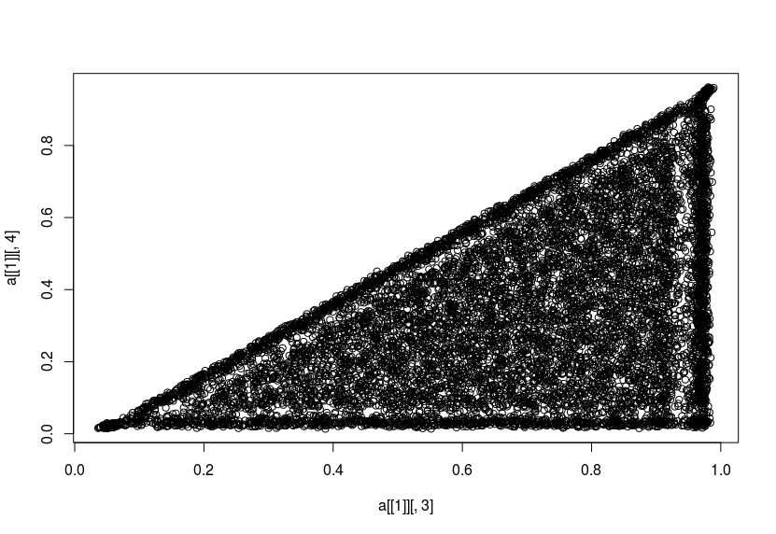

X5 vs X6
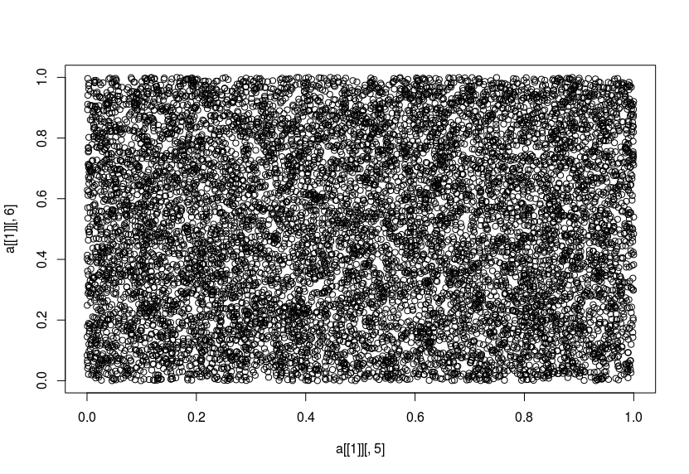
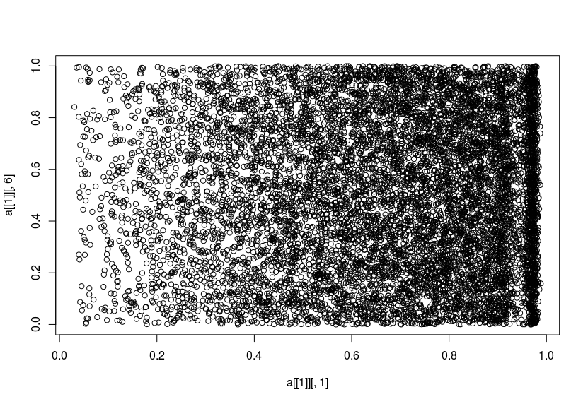

X1 vs X6X1 vs X3
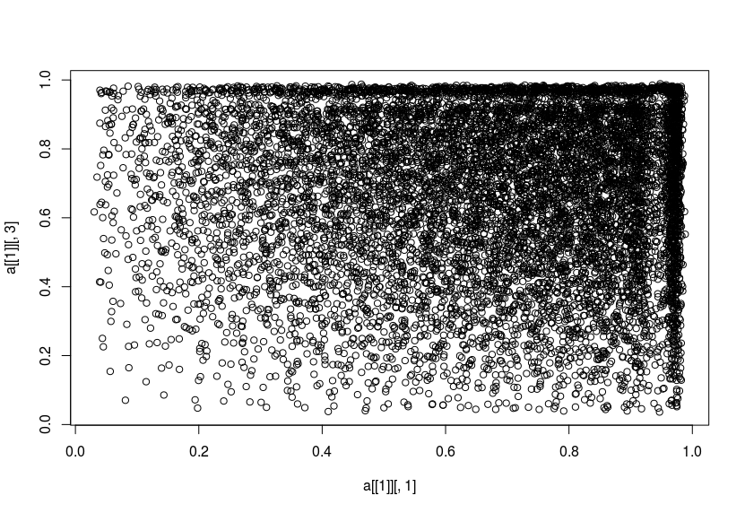

Acknowledgment
The completion of this task could not have been possible without the support and assistance of Dr.V.K Agrawal, Director,CORI and Suresh Jois sir . I’m really thankful to them.
Their work and references have been the great source of knowledge and information for me to perform this project. It have been my privilege of meeting them personally reguarding this project and I'll always be happy to pursue their guidance in future.

References
The template will number citations consecutively within brackets [1]. The sentence punctuation follows the bracket [2]. Refer simply to the reference number, as in [3]—do not use “Ref. [3]” or “reference [3]” except at the beginning of a sentence: “Reference [3] was the first ...”
Number footnotes separately in superscripts. Place the actual footnote at the bottom of the column in which it was cited. Do not put footnotes in the reference list. Use letters for table footnotes.
Unless there are six authors or more give all authors’ names; do not use “et al.”. Papers that have not been published, even if they have been submitted for publication, should be cited as “unpublished” [4]. Papers that have been accepted for publication should be cited as “in press” [5]. Capitalize only the first word in a paper title, except for proper nouns and element symbols.
For papers published in translation journals, please give the English citation first, followed by the original foreign-language citation [6].

- McKay MD, Beckman RJ, Conover WJ. A Comparison of Three Methods for Selecting Values of Input Variables in the Analysis of Output From a Computer Code. Technometrics 1979; 21:239–245.
- Johnson ME, Moore LM, Ylvisaker D. Minimax and Maximin Distance Designs. Journal of Statistical Planning and Inference 1990; 26:131–148.
- Fang KT, Lin DKJ, Winker P, Zhang Y. Uniform Design: Theory and Application. Technometrics 2000; 42(3):237–248.
- Jois, S. (2015). Study, Simulation and Validation of Space Filling Sample Generation Algorithms for Design of Experiments: Report of Phase 1 (Literature Survey). Bangalore.
- Jois, S. (2015). Study, Simulation and Validation of Space Filling Sample Generation Algorithms for Design of Experiments: Final Report of Phase 1: Literature Survey and Proof of Concept code implementation. Bangalore.
- Ramanath, V. (2016). Probabilistic Designs: PES Work Scope – FY2016. Bangalore.
- Jin R, C. W. (2005). An Efficient Algorithm for Constructing Optimal Design of Computer Experiments. Journal of Statistical Planning and Inference, Vol. 134, 268-287.
- Viana, F. A. (2010). An algorithm for fast optimal Latin hypercube design of experiments. International Journal for Numerical Methods in Engineering, volume 62, issue 2, John Wiley & Sons, Ltd., 135-156.
- Santner, T. J. (2013). The design and analysis of computer experiments. In T. J. Santner, The design and analysis of computer experiments. Springer Science & Business Media.
- Golchi, S., & Loeppky, J. L. (2015). Space Filing Designs for Constrained Domains. arXiv preprint arXiv:1512.07328.
- Petelet, M., Ioos, B., Asserin, O., Loredo, A. (2010). Latin hypercube sampling with inequality constraints. arXiv preprint arXiv:0909.0329.
- Sasena, M.J., (2002). Flexibility and Efficiency Enhancements for Constrained Global Design Optimization with Kriging Approximations. PhD Thesis, Dept. of mechanical Engineering, University of Michigan.USA.
- Ryberg, A., (2013). Metamodel based Design Optimization: A Multidisciplinary Approach for Automotive Structures. PhD Thesis, Divisin of Solid Mechanics, Dept. of Management and Engineering, Linkoping University, Sweden.
- Gramacy, R.B., and Lee, H.K.H. (2010). Optimization under unknown constraints. In Bernardo, J.M., Bayarri, M.J., Berger, J.O., Dawid, A.P., Heckerman, D., Smith, A.F.M., and West, M., J eds., Bayesian Statistics 9, 229. Oxford University Press.
- https://cran.r-project.org/web/views/Optimization.html
- List of optimization software. (2016, June 12). In Wikipedia, The Free Encyclopedia. Retrieved 10:09, June 27, 2016, from https://en.wikipedia.org/w/index.php?title=List_of_optimization_software&oldid=724967843
- Myšáková, E., Lepš, M., & Kucerová, A. (2012). A Method for Maximin Constrained Design of Experiments. In Proceedings of the Eighth International Conference on Engineering Computational Technology. Civil-Comp Press, Stirlingshire, UK.
- Lekivetz, R., & Jones, B. (2015). Fast Flexible Space‐Filling Designs for Nonrectangular Regions. Quality and Reliability Engineering International, 31(5), 829-837.
- Benková, E., Harman, R., & Müller, W. G. (2016). Privacy sets for constrained space-filling. Journal of Statistical Planning and Inference, 171, 1-9.

